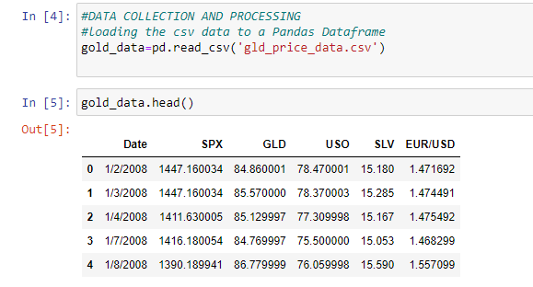

#SPX IS STOCK VALUE GLD IS GOLD PRICE USO IS US OIL PRICE EUR ANF USD IS CURRENCY OF US AND EUROPECURRENCY

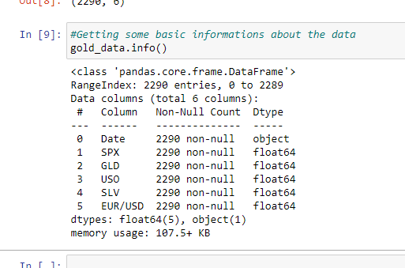

It will show the information of data..

Here non null values means no missing data 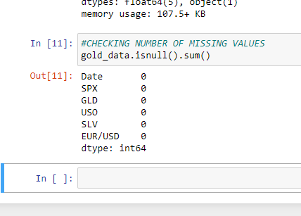

**corelation:**

1.Positive 2.Negative

Positive Co relation:

If any col is directly proportional to another co then it is called directly proportional.

2.Negative :

If inversely proportional

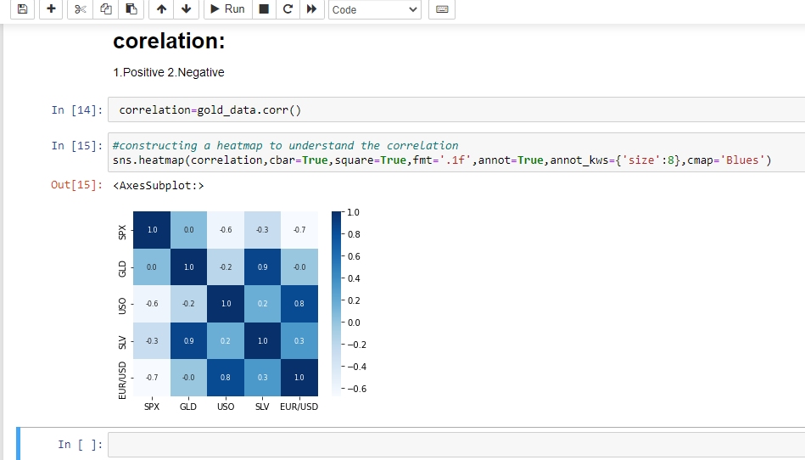

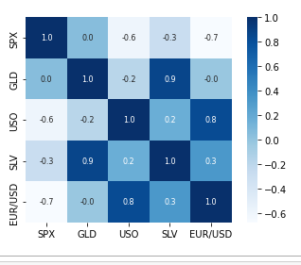

Her Jodi dekhi j somosto value negative tara negatively proposrtional aar jader val pos tara positively co related.

Like here gld aar slv er cross box er val 0.9 that’s mean silv and gld are positively co related…same slv spx er cross box val -0.3 so they are negatively correlated



**correlation likjechi karon et acorelation format

**cbar holo -0.6 theke 1.0 obdi j thamba ta cahe seta..

**square ta true korechi for inner square box

**fmt=.1f mane decimel er por 1 ta value nebe

**annot=True mane char paser j nam gulo acahe slv gls etc etc segulor jonno

Annot_kws holo size debe..

Aar cmap=blues ,mane colour blue debve

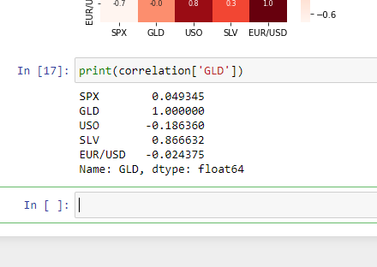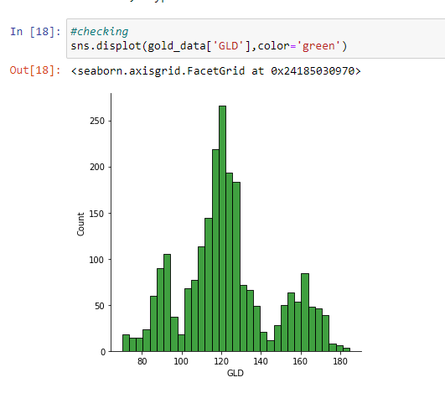

TARGET= GOLD price

FEATURES = US0 USD etc

WE HAVE TO SPLIT THAT:

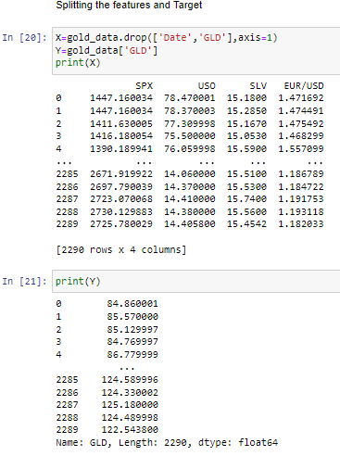

PROTHOME god data r DaTE aar GLD er col k drop korlam and gld ta k y e store korlam aar baki gld ar date chaa table ta xe store korlam

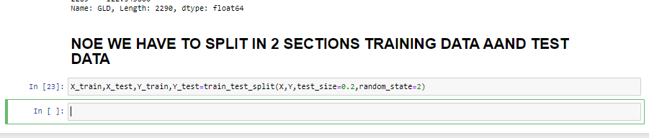



Regressor variable er mopdhye rFR callkore tar dimention dilam 100

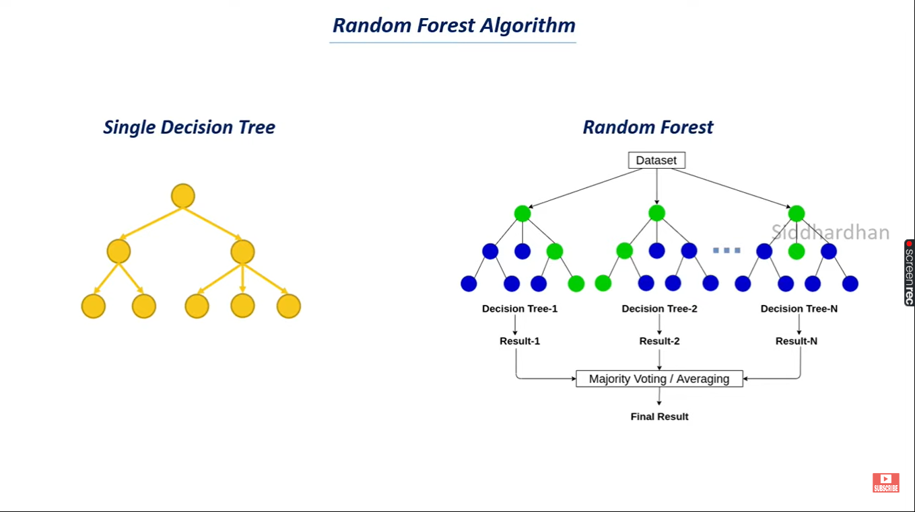

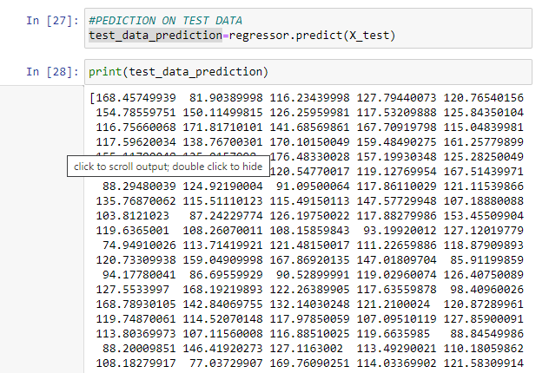

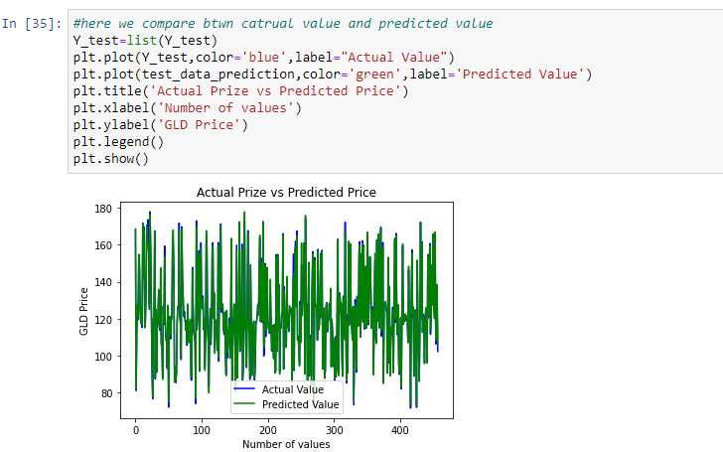

Actual valued graph:

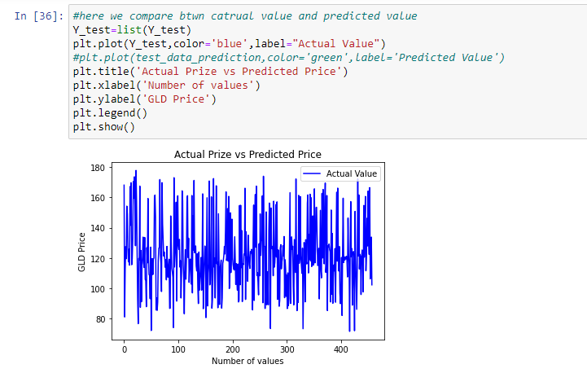

PREDICTED VALUE:

